***Introduction to Trade Life Cycle***

Have you wondered what happens when you initiate a trade, in simple terms when you put an order to buy or sell a stock/shares in the stock market through your trading terminal. To understand trade life cycle, we need to understand detailed steps involved in trade life cycle. Below mentioned are the important steps

1. Order initiation and delivery. (Front office function)

2. Risk management and order routing. (middle office function)

3. Order matching and conversion into trade. (front office function)

**4. Affirmation and confirmation. (back office function)**

5. Clearing and Settlement. (back office function)

**PICTORIAL VIEW OF TRADE CYCLE**

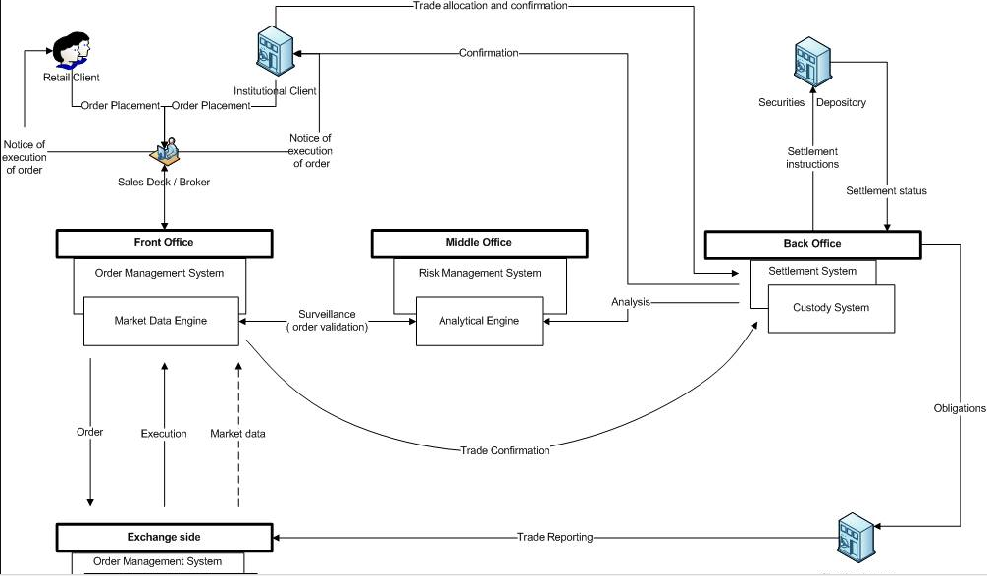

1. **Order initiation and delivery. (Front office function)**

*Who initiates the orders: Retail client like me and you, institutional clients like any Mutual fund company's.* Clients place orders with brokers through telephone, fax , online trading and hand held devices. Orders can be placed either market orders or limit orders, market orders means order to buy or sell is placed at the market price of the share/equity/stock that the investor/client wants to buy/sell whereas limit orders means order placed to buy or sell at a price that investor/client wants to buy/sell. When Broker receives these orders, he/she records these orders carefully so that there is no ambiguity/mistakes in processing.

1. **Risk management and order routing. (middle office function)**

When orders are accepted and sent to exchange these orders go through various risk management checks institutions and clients. Although the risk management checks are more for investors, the underlying assumptions is that they are less creditworthy also due to online trading the client has become faceless, so the risk has increased more. It’s not same for institutional investors because they have a large balance sheet compared to the size of orders they want to place. They also maintain collateral with the members they push their trades through. Their trades are hence subjected to fewer risk management checks than clients.

1. **Order matching and conversion into trade. (front office function)**

* All the orders are collated and sent to the exchange for execution, exchange tries to allot the shares in the best price available to the investors.
* Broker has the record of all the orders that were received from whom, at what time, against which stock, type of order and quantity. Broker maintains these records against client ID.
* Brokers are in real time conversation with exchange so that they have details of how many orders are still pending and how many have been executed in the exchange.
* Once the order is executed it turns into trade and exchange sends notification of the trade to the broker. The broker in turn communicates these trades to the client either immediately or end of day.
* Official communication from broker is done to the client through contract note, which contains details of the trade executed along with taxes being charged and commission being charged by the broker and other institutions like clearing corporation, custodian etc.

1. **Affirmation and confirmation. (back office function)**

Every institution engages the services of an agency called a custodian to assist them in clearing and settlement activities. Institutions specialize in taking positions and holding. To outsource the activity of getting their trades settled and to protect themselves and their shareholder’s interests, they hire a local custodian in the country where they trade. When they trade in multiple countries, they also have a global custodian who ensures that settlements are taking place seamlessly in local markets using local custodians.

As discussed earlier, while giving the orders for the purchase/sale of a security, the fund manager may just be in a hurry to build a position. He may be managing multiple funds or portfolios. At the time of giving the orders, the fund managers may not really have a fund in mind in which to allocate the shares. So, to make more profit and avoid unfavorable market conditions he/she places the order.

The broker accepts this order for execution. On successful execution, the broker sends the trade confirmations to the institution. The fund manager at the institution during the day makes up his mind about how many shares must be allocated to which fund and by evening sends these details to broker. Brokers does a cross verification whether all the allocation details match the trade details and then prepares the contract notes in the names of the funds in which the fund manager has requested allocation.

Along with the broker, the institution also must send details to custodian for the orders it has given to the broker. The institution provides allocation details to the custodian as well. It also provides the name of the securities, the price range, and the quantity of shares ordered. This prepares the custodian, who is updated about the information expected to be received from the broker. The custodian also knows the commission structure the broker is expected to charge the institution and the other fees and statutory levies.

On receipt of the trade details, the custodian sends an affirmation to the broker indicating that the trades have been received and are being reviewed. Trades are validated to check the following:

* Whether trade has happened on the desired security.
* Whether the trade is correct i.e buy or sell.
* The price at which rate it was executed.
* Whether the charges are as per the agreement.

For this verification process the custodian normally runs a various software for recon process. In case the trade details do not match, the custodian rejects the trade, and the trades shift to the broker’s books. It is then the broker’s decision whether to keep the trade (and face the associated price risk) or square it at the prevailing market prices.

1. **Clearing and Settlement. (back office function)**

As we know that there are hundreds and thousands of trades being executed every day and all these trades needs to be cleared and settled. Normally all these trades get settled in T+2 days, which means the trade will gets allotted to the investor to his/her demat account in 2 days from trade date.

The clearing corporation has obligation to every investor in form of

* Funds (for all buy transactions and to those transactions that are not squared for the sale positions).
* Securities (for all the sale transactions done)